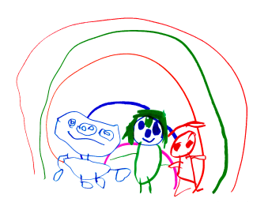
Cambridge Nursery School

PHYSICAL DEVELOPMENT

At Cambridge we recognise how physical development is a thread that runs through all learning. We know that physical development helps improve emotional well-being. We aim to provide a wide range of resources and an environment that supports fine and gross motor development.

What do we mean by gross motor development?

Developing children’s core strength. We do this by spending time on their tummies, throwing, catching, running, carrying, climbing, spending as much time as possible moving.
Developing all their muscles in their upper body and arms to support their fine motor skills. Gross motor skills provide the foundation to develop healthy bodies.

What do we mean by fine motor development?

To develop the ability to control and have precision over hands, fingers, wrists and develop hand eye co-ordination. We use one handed tools and equipment as well as puzzles, small world toys, dough play, gardening. Large outdoor equipment provides the opportunity to develop strength. We encourage children’s physical independence with regard to self-care needs.

At Cambridge we are fortunate to have a large outdoor area with lots of opportunities to develop these skills.
We plan to use MOVER’s (movement environmental rating scales) to audit our provision and improve and focus our practice. Our aim is to maximise the opportunities in our environments (inside and out) to develop teaching and learning of physical development.
This policy will be reviewed annually. Date of next review October 2024.

